Using Harvest Reports on the TMA Dashboard V2.4:

1. Go to: <https://info.tmagrain.com>
2. TMA employees login to this program is the same login that is used to login to your PC. Other coops request your login by clicking the “Request Dashboard Account” link under the login if you do not already have one.

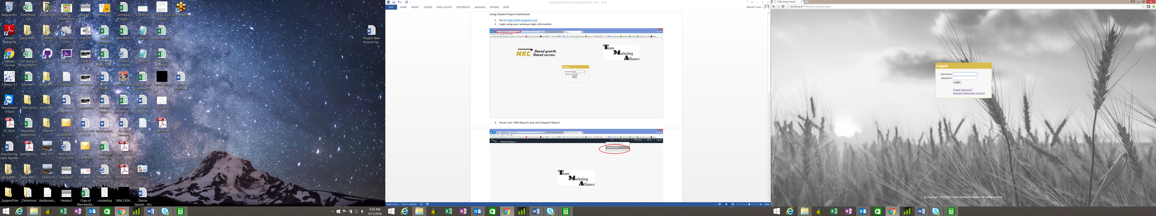

1. When requesting your account login, enter your first name, last name, email address, location and click the “Submit” button. Your account login will be emailed to you within a few minutes. Go back to <https://info.tmagrain.com> and login. 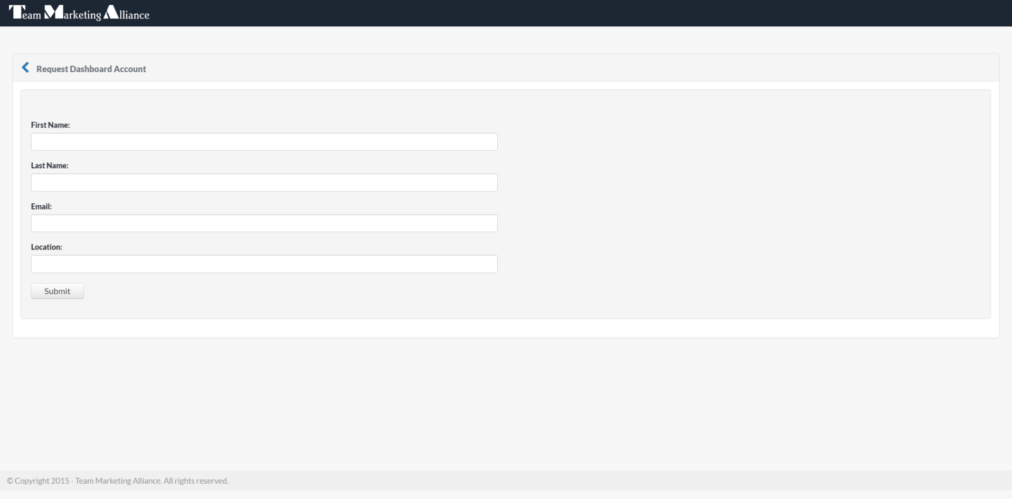
2. Once you have logged in successfully, your home page will look like this:

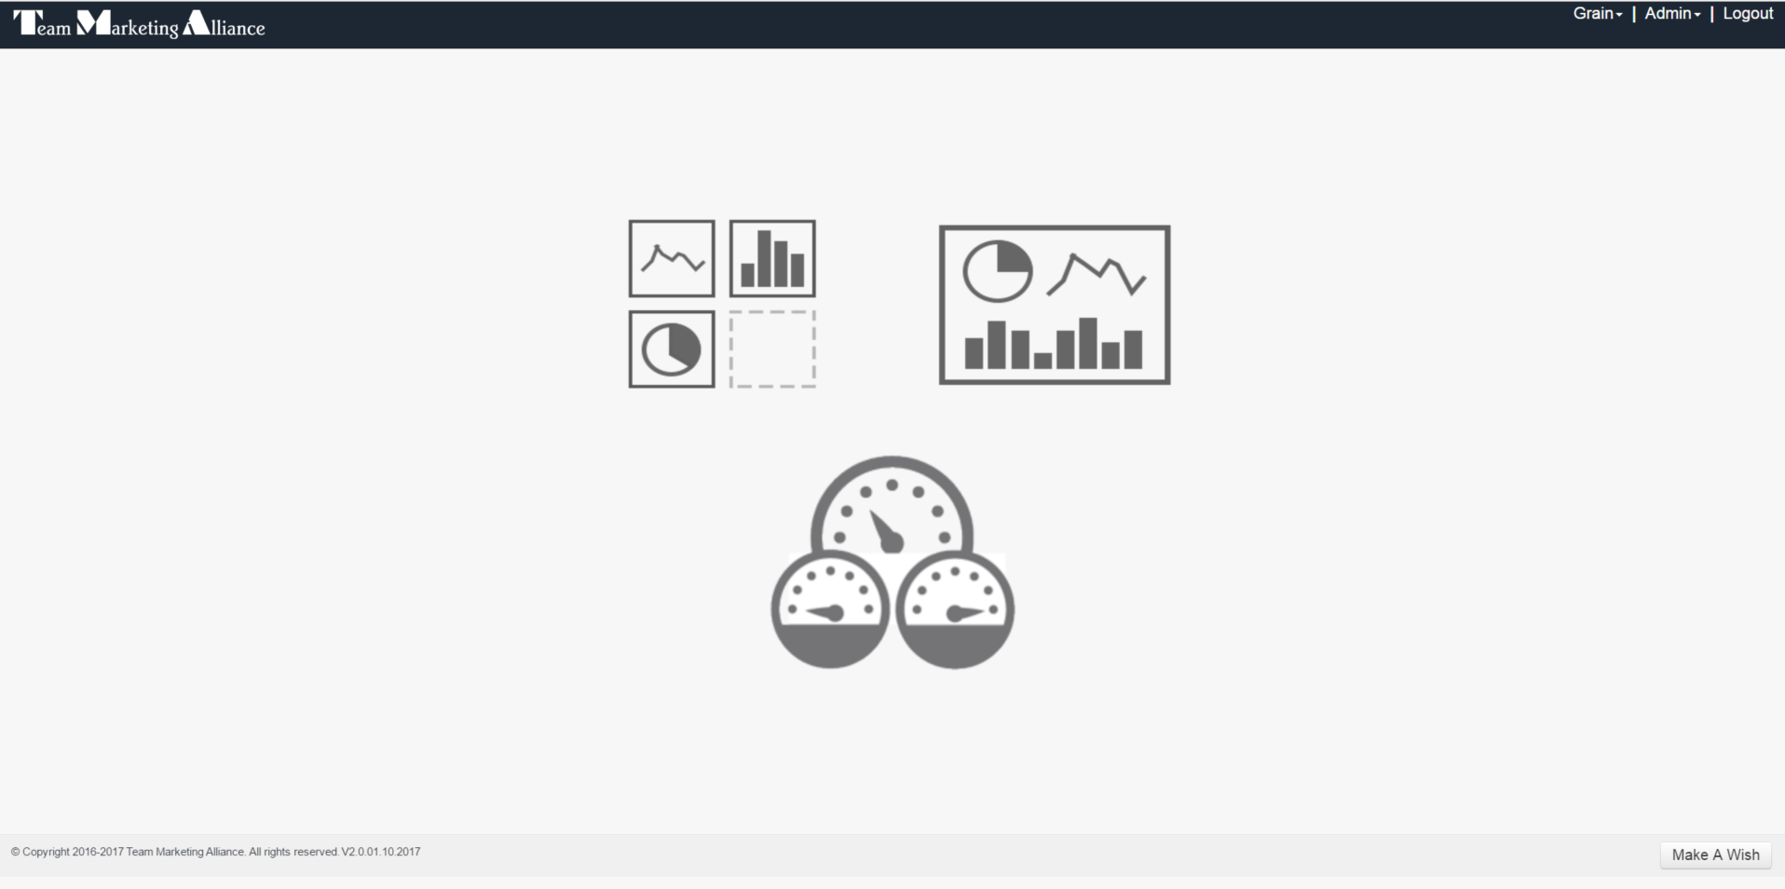

1. To view the Harvest Summary report, point to the “Grain” item in the menu at the top right hand corner of the page to expand the Grain menu. Point to the “Harvest Summary” item in the dropdown menu and click to open.

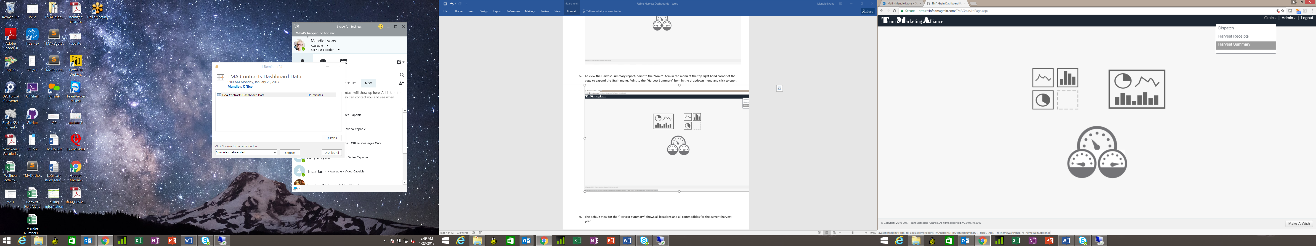

1. The default view for the “Harvest Summary” shows all locations and all commodities for the current harvest year.

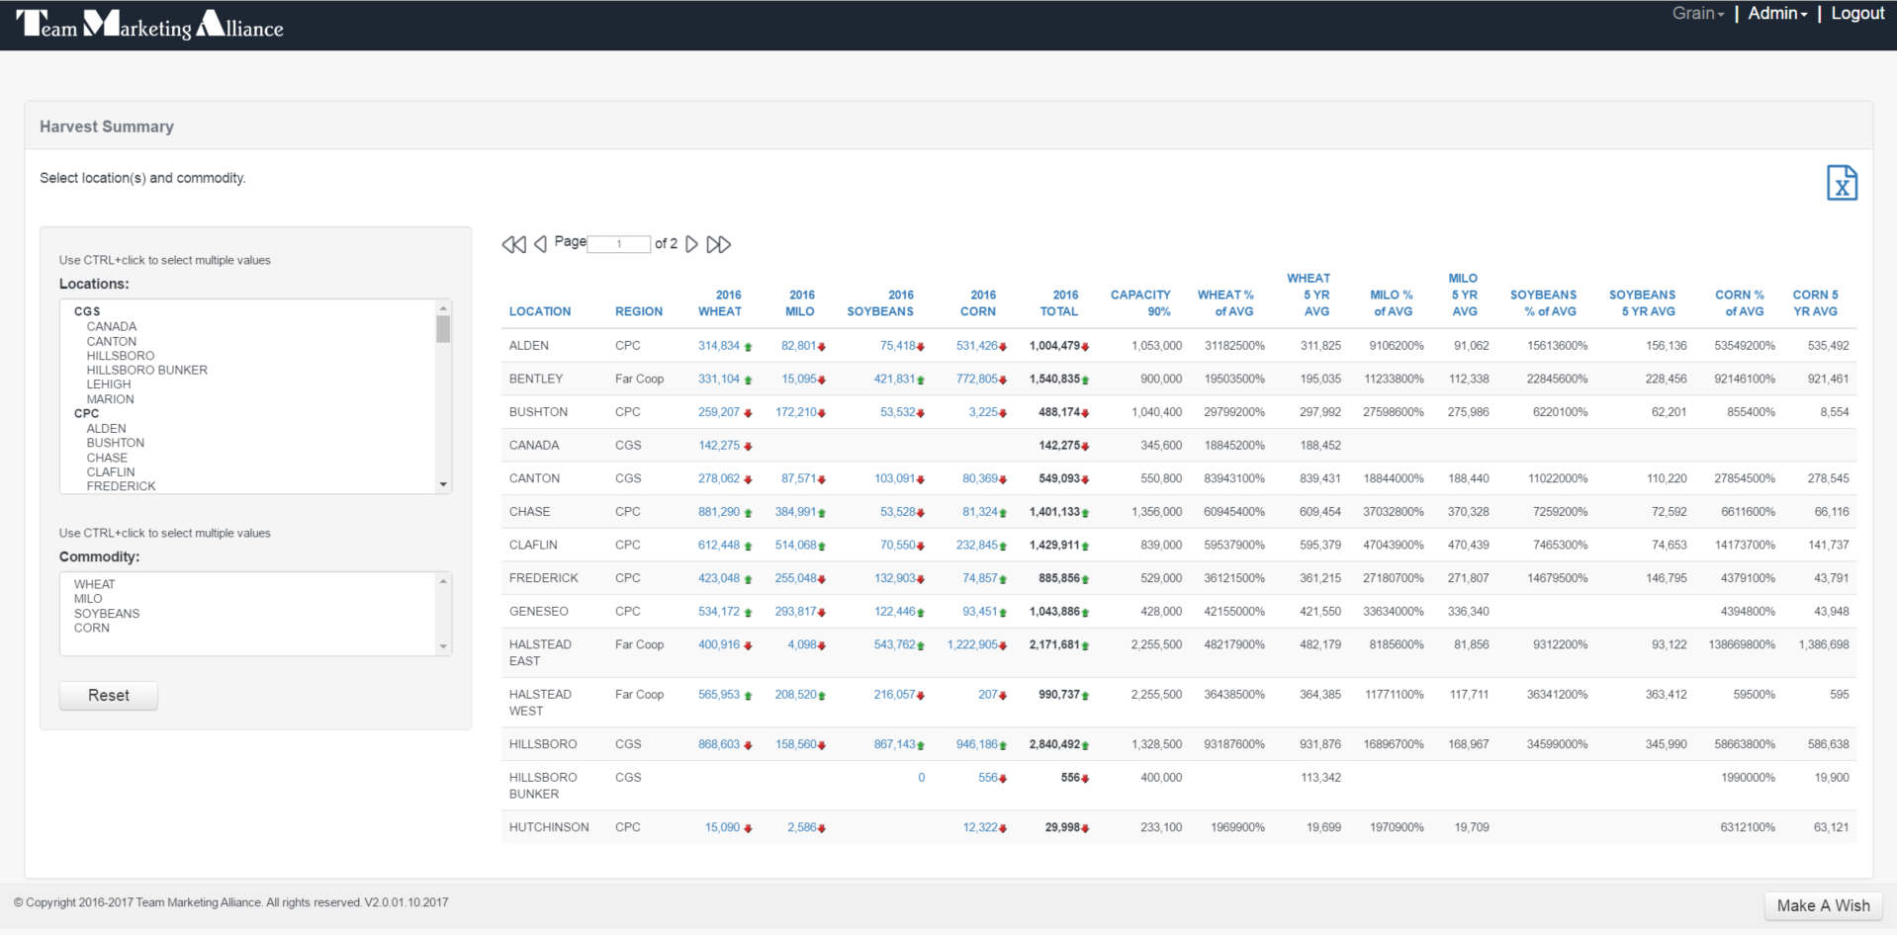

1. Filter by the location(s) you want to view using CTRL + click. In the same way, filter by commodities you want to view. You may select multiple locations and multiple commodities.

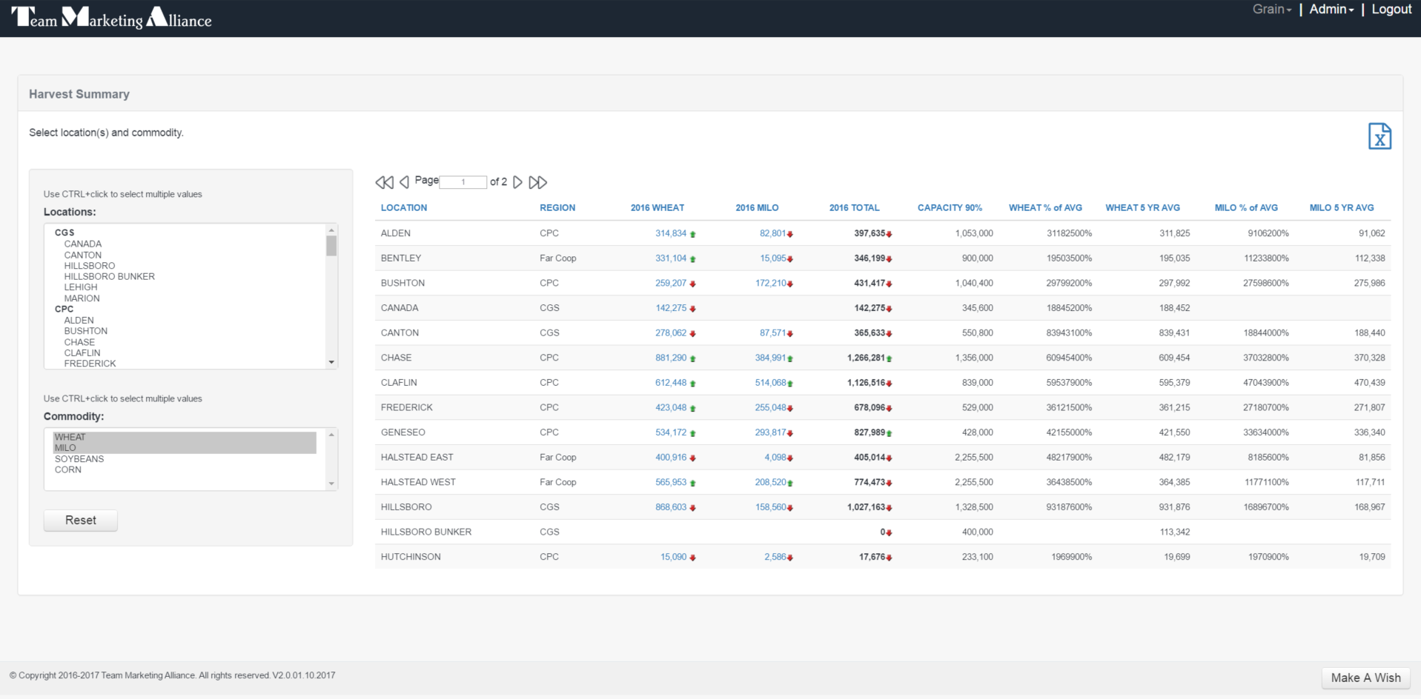

1. To view the “Harvest Receipts” report for a specific commodity and location, click the commodity value for the location as show below:

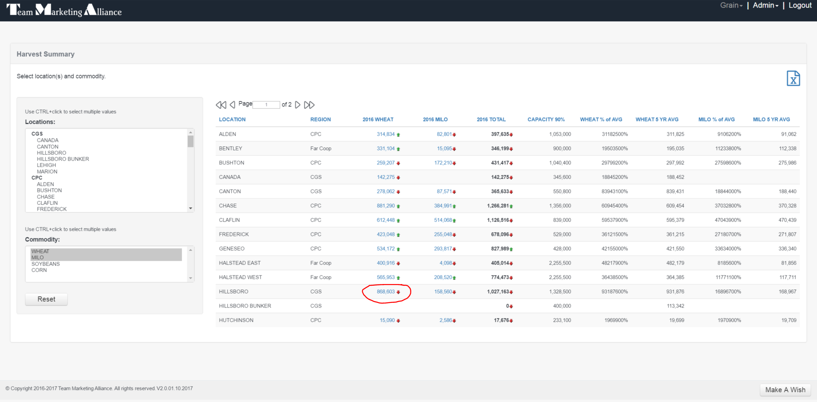

1. To return to the “Harvest Summary”, click the “<” link.

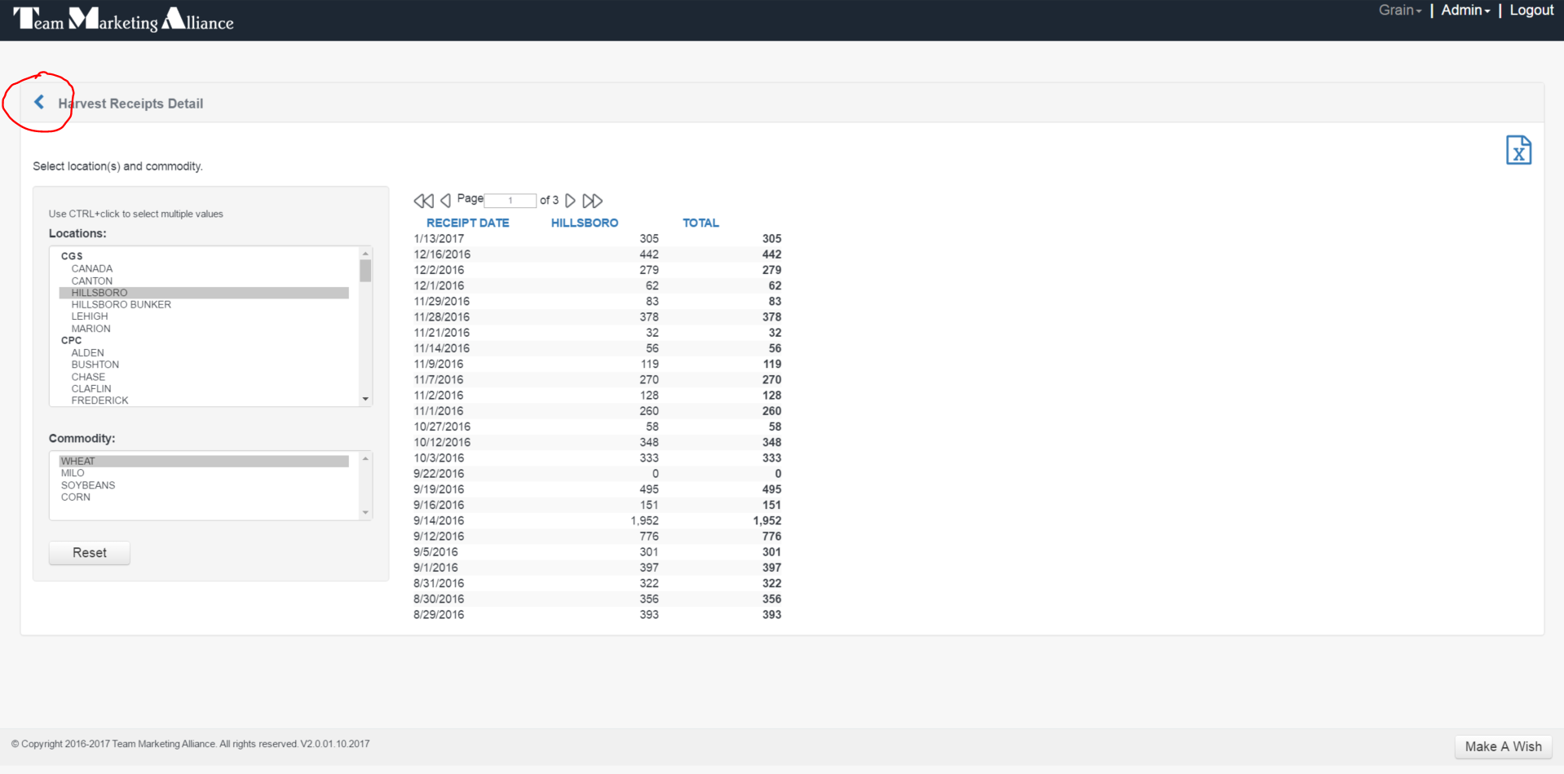

1. To view the “Harvest Receipts” report, point to the “Grain” item in the menu at the top right hand corner of the page to expand the Grain menu. Point to the “Harvest Receipts” item in the dropdown menu and click to open.

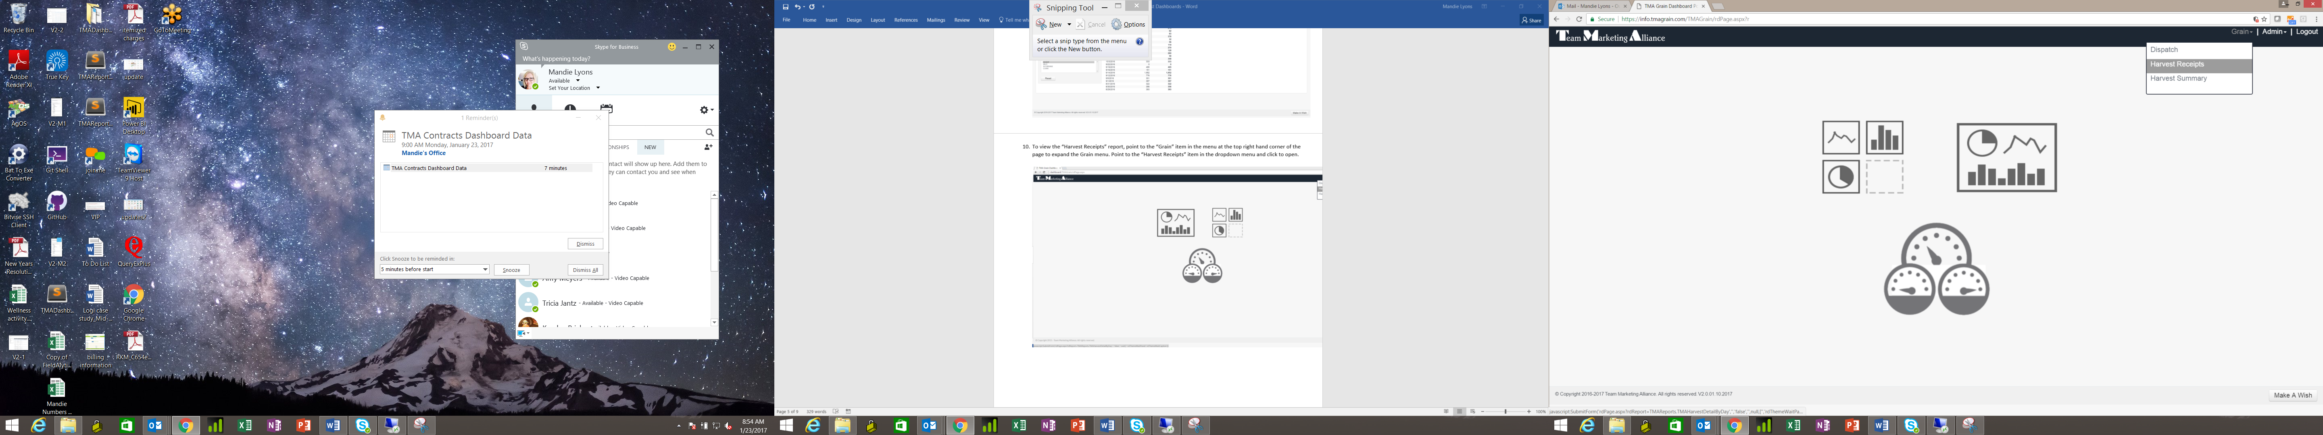

1. Point to the “Harvest Receipts” item in the dropdown menu and click to open.

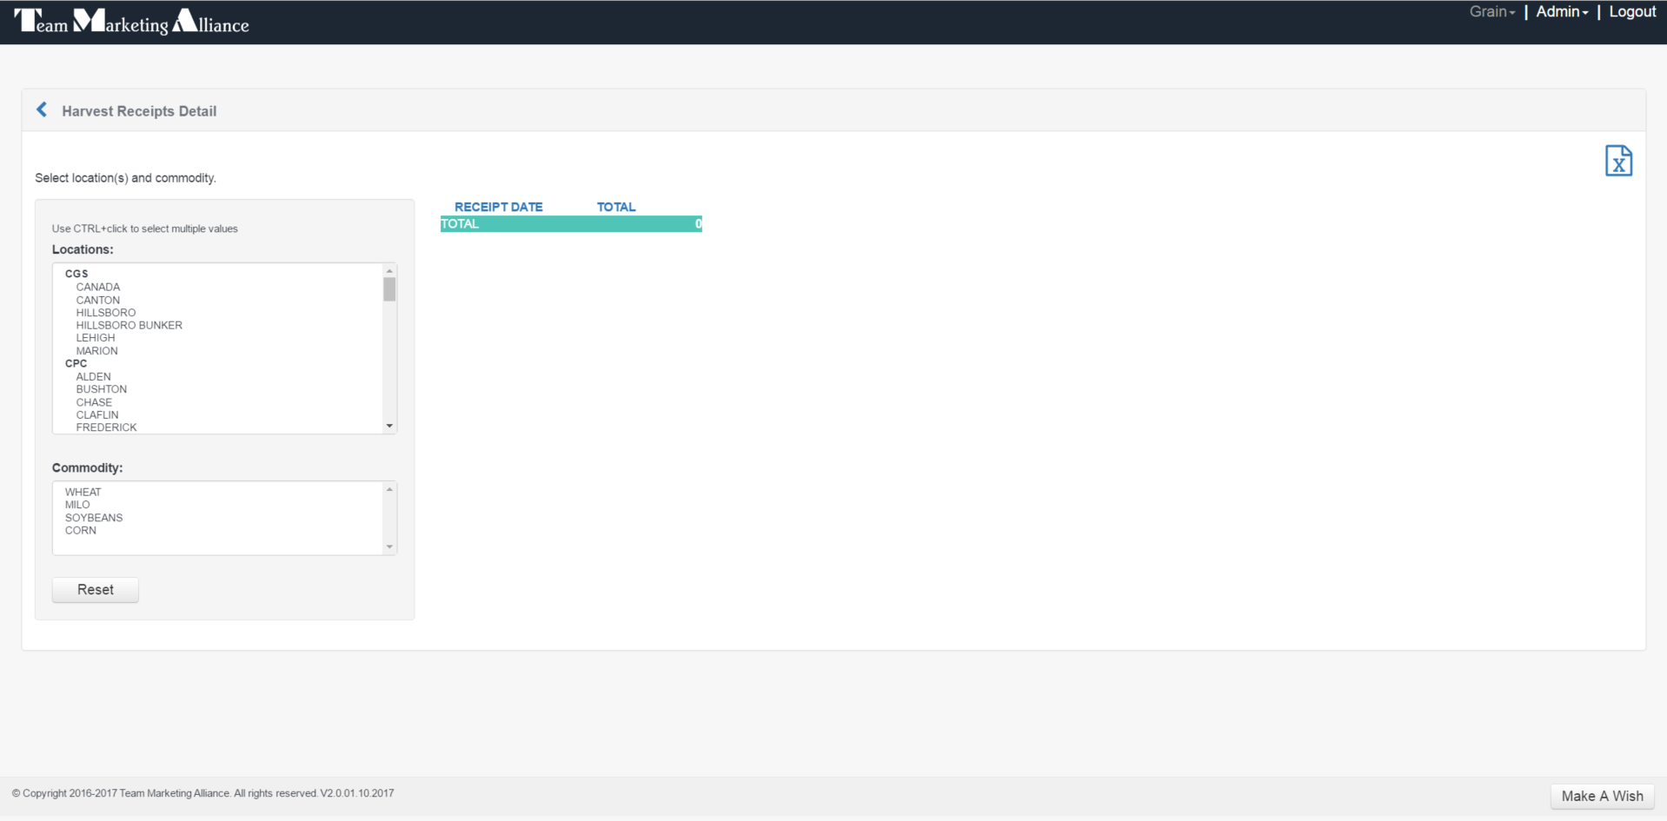

1. Choose the location(s) you want to see then click on the commodity. You can choose multiple locations by using CTRL + click but you can only choose one commodity.

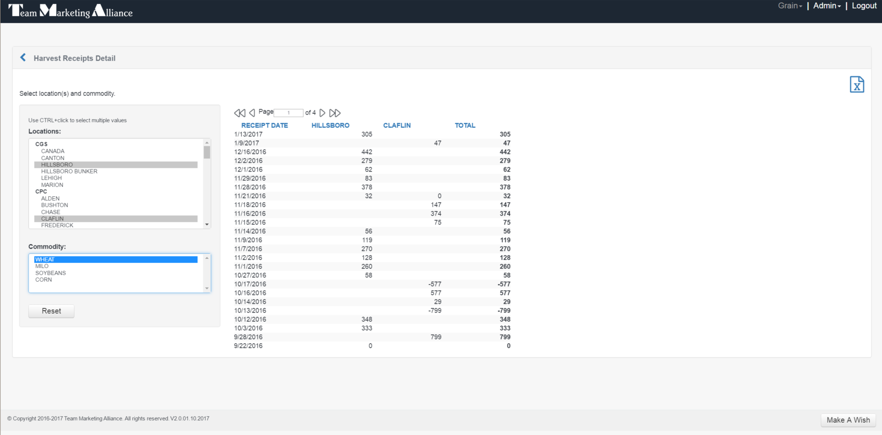

1. Click the “Reset” button to clear the selections.

